Sixth Form Virtual Open Evening – Joining Details
Wednesday 14 October

Please find below the links to join the two Sixth Form Open Evening Overview Presentation live streams. Please note that the content will be the same in both, so please join the one most convenient to you, they will each last approximately 25 minutes.
Sixth Form Open Evening Live Stream 1 – 6:30pm
Sixth Form Open Evening Live Stream 2 – 8.00pm

The best experience will be via a PC, laptop or Mac, due to the screen size.
When you click the link above, you will be asked to open Microsoft Teams.
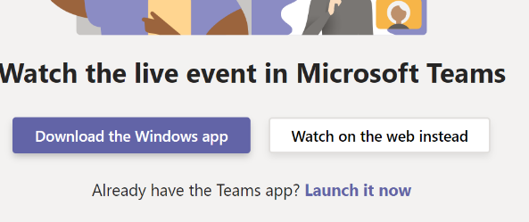
Windows: On a PC or laptop you can open this in the Teams app if this is installed, or directly in the browser (Chrome, Firefox or Edge) by clicking ‘Watch on the web instead’. Please note you will not be able to access the event in Internet Explorer.
Mac: On a Mac you can watch in the Teams app or via the Chrome, Firefox or Edge browsers by clicking ‘Watch on the web instead’. Please note you will not be able to access the event in Safari.
Tablet or Mobile Phone: If you want to watch on a tablet or mobile phone you will need to download the Microsoft Teams app to watch the stream. The link should automatically open in the Teams app, or you may be taken to a webpage which asks you to open the Teams app. You can download the iOS Teams app here or the Android Teams app here
You can join the event by signing in if you have an existing Teams account, or anonymously by clicking ‘join anonymously’ or ‘join as a guest’.
It may say that the live event has yet to start. Please simply wait until the event begins.
The presenters will not be able to see or hear you, it is purely a live stream to view.
You can watch a recording of the either presentation after it has finished by clicking on the relevant link above again.

Troubleshooting
Please ensure your sound is turned on to hear the presentation.
If you are disconnected at any time, the event should automatically reconnect. If it does not reconnect, or you join the event late you can click the link above to join again. It should re-join you live, but you can use the slider at the bottom of the video to move back to the start or to an earlier point in the event if you have missed anything.
If you are watching on an iPad, iPhone or Android tablet and the link fails to open the app correctly, you should long press on the link and then select ‘Open in Teams app’.
For more details on attending a Teams Live Event, please see the support page here

